**Assignment # 1**

**CSCS 351 (SQA)**

**Name: Joshua Naeem (22-10367)**

**Instructor: Dr. Saad Bin Saleem**

**TEST SUITE:**

My test suite named: (TestLibrary) consists of 5 test cases names are:

1. test_availablebooks
2. test_lendbook
3. test_add_book
4. test_new_book
5. test_delete_book

**Introduction**

This test suite will test 5 test cases mentioned above from a python file library.py using unittesting module of Python.

**Major functions/library used:**

* **import unittest**
* **from library import Library:**  this line tells the python interpreter to include the Library class from the library.py python file.
* **def setUp(self):** this function helps to initiate the class objects later being used in the test cases.

**The Tested Program (library.py):**

class Library:

    def __init__(self,listofbooks):

        self.listofbooks = listofbooks

    def get_available_books(self):

        return self.listofbooks

    def lendbook(self, requestedbook):

        if requestedbook in self.listofbooks:

            print("")

        else:

            print("Sorry the book you have requested is currently not in the library")

        return requestedbook

    def add_book(self,returnedbook):

        return returnedbook

    def new_book(self, new):

        return new

    def delete_book(self, delete):

        return delete

**The Testing Program (test_library.py):**

import unittest

from library import Library

class TestLibrary(unittest.TestCase):

    def setUp(self):

        self.c = Library(['Harry Potter','The Last Airbender', 'Multiverse of Madness'])

        self.c.lendbook('Harry Potter')

        self.c.add_book('Garvin Adventures')

        self.c.new_book('James Harold')

        self.c.delete_book('Harry Potter')

    #test_case_1

    def test_availablebooks(self):

        print('test_availablebooks')

        self.assertEqual(self.c.get_available_books(), ['Harry Potter','The Last Airbender', 'Multiverse of Madness'])

    #test_case_2

    def test_lendbook(self):

        print('test_lendbook')

        self.assertEqual(self.c.lendbook('Harry Potter'), 'Harry Potter')

    #test_case_3

    def test_add_book(self):

        print('test_add_book')

        self.assertEqual(self.c.add_book('Garvin Adventures'), 'Garvin Adventures')

    #test_case_4

    def test_new_book(self):

        print('test_new_book')

        self.assertEqual(self.c.new_book('James Harold'), 'James Harold')

    #test_case_5

    def test_delete_book(self):

        print('test_delete_book')

        self.assertEqual(self.c.new_book('Harry Potter'), 'Harry Potter')

if __name__ == '__main__':

    unittest.main()

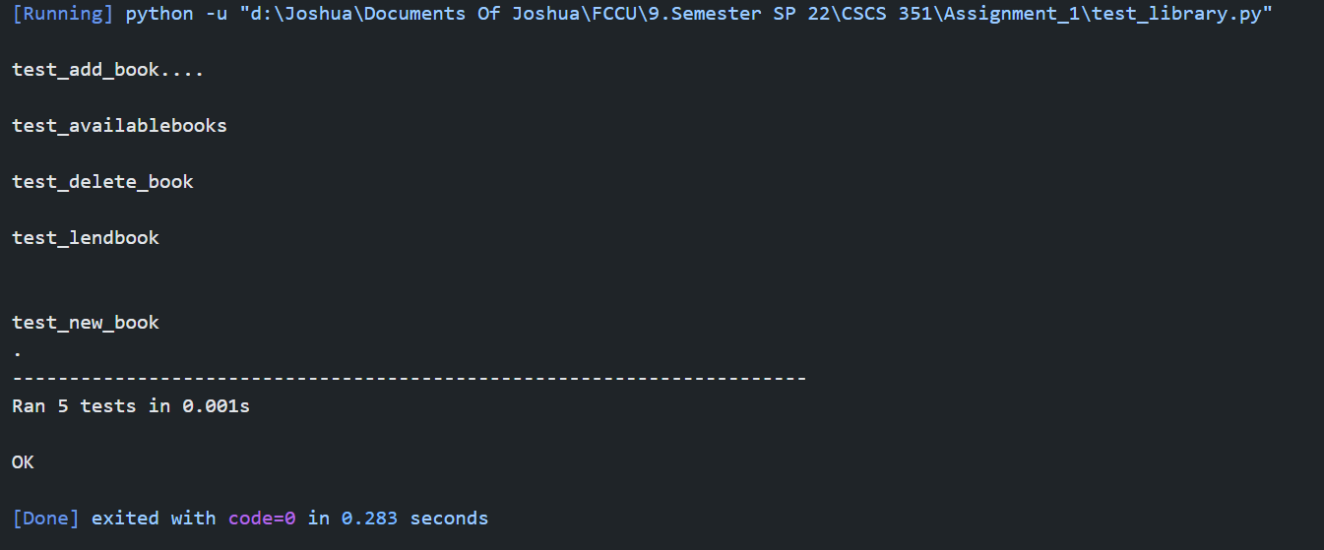**Output:**

**Results:**

5 out of 5 test cases are valid!